Department of Electrical Engineering
The Superior University, Lahore

Computer Programming

Experiment No.8
Introduction to Arrays

Prepared for:
Eisha Nawaz
By:
Name: Tanseer Haider
ID: SU91-BSEEM-F25-002
Section: Electrical Engineering Fall 25
Semester: 2nd

Total Marks: ______10_________
Obtained Marks: ______________
Signature: __________________
Date: __________________

Experiment No.8
Introduction to Arrays
(Rubrics)

Name: Tanseer Haider ID: SU91-BSEEM-F25-002

- PSYCHOMOTOR
Serial No. | Criteria | Allocated Marks | Unacceptable  0% | Poor  25% | Fair  50% | Good  75% | Excellent  100% | Total Obtained
1 | Syntax Handling | 1 | 0 | 0.25 | 0.5 | 0.75 | 1
2 | Program Coding Skills | 2 | 0 | 0.5 | 1 | 1.5 | 2
3 | Accuracy in Output Results | 3 | 0 | 0.75 | 1.5 | 2.25 | 3
Sub-Total |  | 6 | Sub Total Marks Obtained in Psychomotor (P)

- AFFECTIVE
Serial No. | Criteria | Allocated Marks | Unacceptable  0% | Poor  25% | Fair  50% | Good  75% | Excellent  100% | Total Obtained
1 | Lab Report | 2 | 0 | 0.5 | 1 | 1.5 | 2
2 | Assigned Task | 2 | 0 | 0.5 | 1 | 1.5 | 2
Sub-Total |  | 4 | Sub Total Marks Obtained in Affective (A)

Instructor Name: | __Eisha Nawaz__ | Total Marks (P+A): | ______________
Instructor Signature: | ______________ | Obtained Marks (P+A): | ______________

Contents of Lab 8
1 Objectives 4
2 Arrays in C++ 4
2.1 Declaration of Arrays 4
2.1.1 Example 1 4
2.2 Initializing Arrays 5
2.2.1 Example 2 5
2.3 Accessing Array Elements 5
2.3.1 Few Things to Remember: 6
2.4 Array Initialization 6
2.4.1 Example 3 6
2.5 Array With Empty Members 6
2.5.1 Example 4 7
2.6 Inserting and Printing Array Elements 7
2.6.1 Example 5 7
2.7 Displaying Array Elements 7
2.7.1 Example 6 8
2.8 Take Inputs From User To Store Elements in Array and Printing the Stored Values 8
2.8.1 Example 7 8
2.8.2 Example 8 9
3 Lab Tasks 10
3.1 Task 1 10
3.2 Task 2 10
3.3 Task 3 10
3.4 Task 4 10
3.5 Task 5 10
3.6 Task 6 10
4 Home Assignment: 10
4.1 Task 1 10
4.2 Task 2 10
4.3 Task 3 10

Introduction to Arrays

Objectives
- To get a basic understanding of arrays in C++.
- To understand the basics of 1D arrays.
- To get hands-on experience working with 1D arrays.
- To declare, initialize, and access array elements in C++ programming with the help of examples.

Arrays in C++
C++ provides a data structure, the array, which stores a fixed-size sequential collection of elements of the same type. An array is used to store a collection of data, but it is often more useful to think of an array as a collection of variables of the same type.
Instead of declaring individual variables, such as number0, number1, ..., and number99, you declare one array variable such as numbers and use numbers [0], numbers [1], and ..., numbers [99] to represent individual variables. A specific element in an array is accessed by an index.
All arrays consist of contiguous memory locations. The lowest address corresponds to the first element and the highest address to the last element.

Declaration of Arrays
To declare an array in C++, the programmer specifies the type of the elements and the number of elements required by an array as follows −
dataType arrayName [arraySize];
This is called a single-dimension array. The arraySize must be an integer constant greater than zero and type can be any valid C++ data type. For example, to declare a 10-element array called balance of type double, use this statement −

Example 1
An example of declaration of an array is given as follows:
int x [6];
Here,
- int - type of element to be stored
- x - name of the array
- 6 - size of the array

Initializing Arrays
You can initialize C++ array elements either one by one or using a single statement as follows −
double balance [5] = {1000.0, 2.0, 3.4, 17.0, 50.0};
The number of values between braces { } cannot be larger than the number of elements that we declare for the array between square brackets [ ].

Example 2
Following is an example to assign a single element of the array:
If you omit the size of the array, an array just big enough to hold the initialization is created. Therefore, if you write:
double balance [] = {1000.0, 2.0, 3.4, 17.0, 50.0};
You will create exactly the same array as you did in the previous example.
balance [4] = 50.0;
The above statement assigns element number 5th in the array a value of 50.0. Array with 4th index will be 5th, i.e., last element because all arrays have 0 as the index of their first element which is also called base index. Following is the pictorial representation of the same array we discussed above −
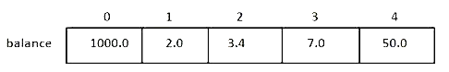
Figure 1: Example of Array

Accessing Array Elements
An element is accessed by indexing the array name. This is done by placing the index of the element within square brackets after the name of the array.
In C++, each element in an array is associated with a number. The number is known as an array index. We can access elements of an array by using those indices.
// syntax to access array elements
array[index];
Consider the array x we have seen above.
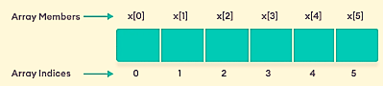
Figure 2: Elements of Array in C++

Few Things to Remember:
- The array indices start with 0. Meaning x[0] is the first element stored at index 0.
- If the size of an array is n, the last element is stored at index (n-1). In above example, x[5] is the last element.
- Elements of an array have consecutive addresses. For example, suppose the starting address of x[0] is 2120d. Then, the address of the next element x[1] will be 2124d, the address of x[2] will be 2128d and so on.d
Here, the size of each element is increased by 4. This is because the size of int is 4 bytes.

Array Initialization
In C++, it's possible to initialize an array during declaration.

Example 3
For example,
// declare and initialize and array
int x[6] = {19, 10, 8, 17, 9, 15};
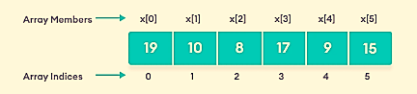
Figure 3: Array Elements and Their Data
Another method to initialize array during declaration:
// declare and initialize an array
int x[] = {19, 10, 8, 17, 9, 15};
Here, we have not mentioned the size of the array. In such cases, the compiler automatically computes the size.

Array With Empty Members
In C++, if an array has a size n, we can store up to n number of elements in the array. However, what will happen if we store less than n number of elements.

Example 4
For example,
// store only 3 elements in the array
int x[6] = {19, 10, 8};
Here, the array x has a size of 6. However, we have initialized it with only 3 elements.
In such cases, the compiler assigns random values to the remaining places. Oftentimes, this random value is simply 0.
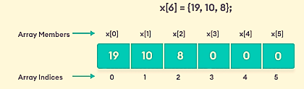
Figure 4: Empty Array Elements Are Automatically Assigned 0

Inserting and Printing Array Elements
The example of inserting and printing elements in an array is as follows:

Example 5
The code and output is given as follows:
Code
int mark[5] = {19, 10, 8, 17, 9}

// change 4th element to 9
mark[3] = 9;
// take input from the user
// store the value at third position
cin >> mark[2];

// print first element of the array
cout << mark[0];

Displaying Array Elements
The example of displaying array elements is shown below:

Example 6
Code | Output
#include <iostream>  using namespace std;  int main() {  int n[5]; //Declaring Array  //Storing Array Elements  n[0]=1;  n[1]=2;  n[2]=3;  n[3]=4;  n[4]=5;  // Printing array elements  cout<<”Value Stored at Index 0 is :”<<n[0]<<endl;  cout<<”Value Stored at Index 1 is :”<<n[1]<<endl;  cout<<”Value Stored at Index 2 is :”<<n[2]<<endl;  cout<<” Value Stored at Index 3 is :”<<n[3]<<endl;  cout<<”Value Stored at Index 4 is :”<<n[4]<<endl;  return 0;  } | Value Stored at Index 0 is :1  Value Stored at Index 1 is :2  Value Stored at Index 2 is :3  Value Stored at Index 3 is :4  Value Stored at Index 4 is :5

Take Inputs From User To Store Elements in Array and Printing the Stored Values
The given example uses for-loop to take input from user.

Example 7
We have used a for loop to iterate from i = 0 to i = 4. In each iteration, we took an input from the user and stored it in numbers[i].
Then, we used another for loop to print all the array elements.
Code | Output
#include <iostream>  using namespace std;  int main() {  int numbers[5];  cout << "Enter 5 numbers: " << endl;  // store input from user to array  for (int i = 0; i < 5; ++i) {  cin >> numbers[i];  }  cout << "The numbers are: ";  // print array elements  for (int n = 0; n < 5; ++n) {  cout << numbers[n] << " ";  }  return 0;  } | Enter 5 numbers:  11  12  13  14  15  The numbers are: 11 12 13 14 15

Example 8
Following program is displaying and printing one dimensional array.
Code | Output
#include<iostream>  using namespace std;  int main()  {  int arr[50], num, i;  cout<<"\n How Many Elements You Want to Store into an Array? \n";  cin>>num;  cout<<"\n Enter "<<num<<" Elements to Store into an Array : \n";  for(i=0; i<num; i++)  {  cin>>arr[i];  }  cout<<"\n The Elements in the Array are : \n";  for(i=0; i<num; i++)  {  cout<<arr[i]<<"\t";  }  return 0;  } | How Many Elements You Want to Store into an Array?  6  Enter 6 Elements to Store into an Array  1  2  3  4  5  The Elements in the Array are:  1 2 3 4 5 6

The foreach Loop
There is also a "for-each loop" (introduced in C++ version 11 (2011)), which is used exclusively to loop through elements in an array (and other data structures, like vectors and lists):

Syntax
for (type variableName : arrayName) {
// code block to be executed
}

Lab Tasks
Voltage Readings Across 7 Circuit Test Points
A technician probes 7 test points along a circuit board and records the voltage at each one. You will store these readings in a 1D array and analyze them for extremes, averages, out-of-range values, and ranked order — a simplified version of the checks a bench technician runs before signing off a board.

Concepts Covered in This Lab
- Declaring and initializing a 1D array with real measured values
- Traversing an array with a single loop to display its contents
- Finding the maximum and minimum value in an array
- Computing the sum and average of all elements
- Linear search for a user-specified value
- Counting elements that satisfy a condition
- Sorting an array in ascending and descending order (in place, no second array)

Starter Code
Complete the TODO sections directly inside main(). No user-defined functions are used — every operation is written using loops and conditionals inside main().
#include <iostream>
using namespace std;

int main() {
// 1D array holding voltage readings (Volts) from 7 test points
double voltage[7] = {11.8, 12.1, 12.4, 11.5, 12.0, 13.2, 10.9};

int i, j;
double sum = 0.0, average = 0.0;
double maxV = voltage[0], minV = voltage[0];
double searchValue;
int safeCount = 0;
double lowLimit = 11.0, highLimit = 13.0;
double tempSwap;

// ---------- TODO 1: Display all readings ----------
// Loop through voltage[0..6] and print "Test Point i: value V"

// ---------- TODO 2: Find the maximum and minimum voltage ----------
// Loop through the array, updating maxV / minV whenever you find a
// larger or smaller value than the current maxV / minV.

// ---------- TODO 3: Compute the sum and average voltage ----------
// Add every element to sum inside a loop, then divide by 7 for average.

// ---------- TODO 4: Search for a specific voltage ----------
// Ask the user to enter searchValue. Loop through the array; if a
// match is found print its test-point index, otherwise print
// "Value not found" after the loop completes.

// ---------- TODO 5: Count readings within the safe range ----------
// Loop through the array and count how many readings are between
// lowLimit and highLimit (inclusive). Print the count.

// ---------- TODO 6: Sort the readings ----------
// Using two nested loops over voltage[] itself (a simple selection or
// bubble sort, swapping with tempSwap — no second array), sort the
// array in ascending order and print it, then sort it again in
// descending order and print it.

return 0;
}

Sub-Tasks
Task 1: Display the array
Loop once through all 7 elements and print each test point's index alongside its voltage. This is the foundation every later task builds on.
Task 2: Maximum and minimum
Keep two running variables (maxV, minV), initialized to the first element, and update them as you scan the rest of the array.
Task 3: Sum and average
Accumulate every element into a running total, then divide by the array size (7) to get the average — the array-based version of the reduction you practiced in the multidimensional lab, now on a single dimension.
Task 4: Linear search
Ask the user for a value, then scan the array element by element comparing against it. Report the index if found, or a clear 'not found' message if the loop finishes without a match.
Task 5: Conditional counting
Scan the array and increment a counter every time a reading falls inside the safe voltage range.
Task 6: In-place sorting
Use a simple sort (bubble or selection) with two nested loops directly on voltage[] to reorder it ascending, print it, then reorder it descending and print it again.

Expected Outcome
- All 7 readings printed with their test-point index.
- Maximum = 13.2 V (test point 5), Minimum = 10.9 V (test point 6).
- Sum ≈ 84.9, Average ≈ 12.13 V.
- Searching for 12.4 reports test point 2; searching for a value not present reports 'not found'.
- Safe-range count = 5 (all except 13.2 and 10.9, which fall outside 11.0-13.0).
- Ascending sort: 10.9, 11.5, 11.8, 12.0, 12.1, 12.4, 13.2. Descending sort reverses this order.
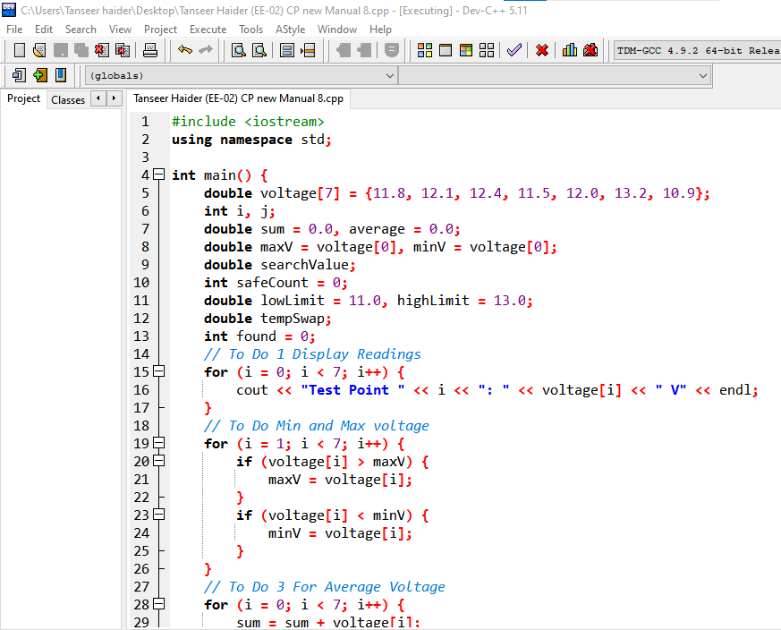
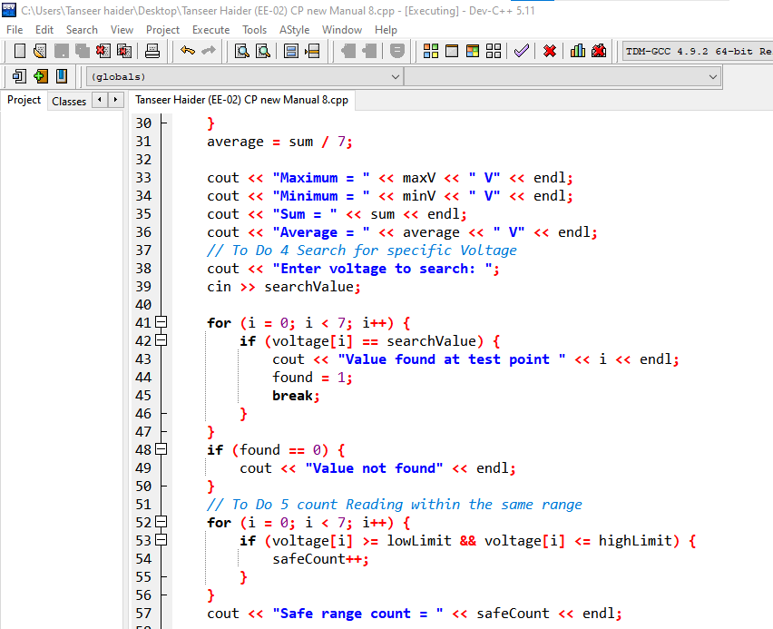
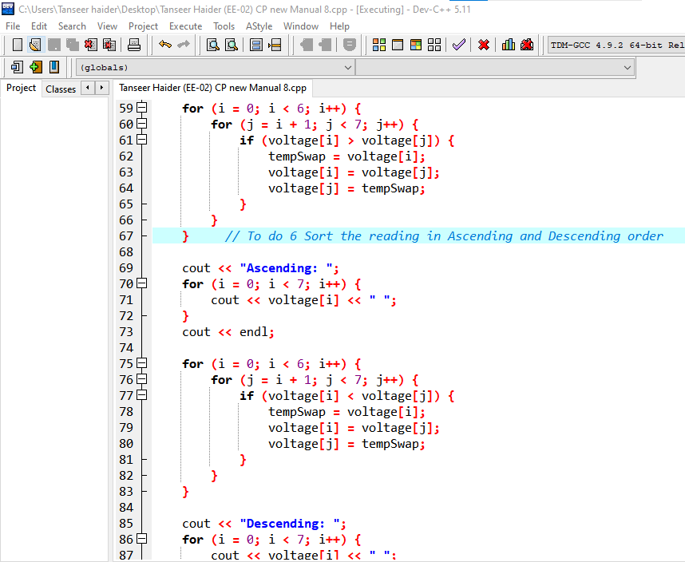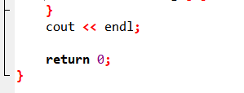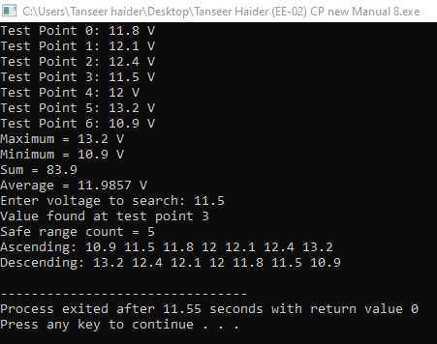

Hands-On Practice Exercises (Do Independently)
Write these as separate standalone programs, without referring back to the starter code, to confirm you have understood the concept on your own.
- Create an array current[5] holding current readings (A) from 5 feeders. Compute and print the total and average current.
- Create an array resistors[6] of resistance values (Ω). Without using a second array, find and print the two largest values.
- Create an array power[5] of power consumption (W) for 5 devices. Count how many exceed 100W, then sort the array in descending order to rank devices by consumption.

